Hibernate solution L1

Event Manager:

1. SaveLocations:

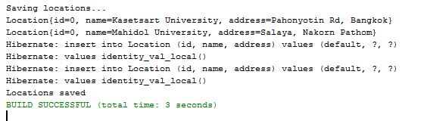

2. Retrieving Locations:

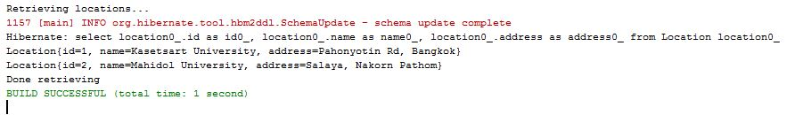

3. Updating Locations:



4. Retrieving Locations after updating:

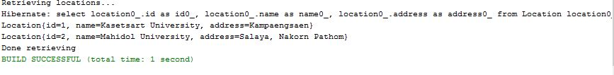

5. Saving Events:



6. Retrieving Events:

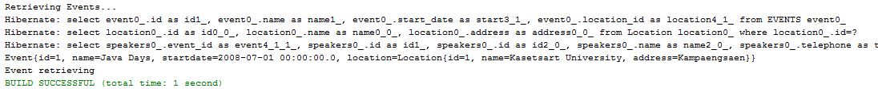

7. Updating Events:

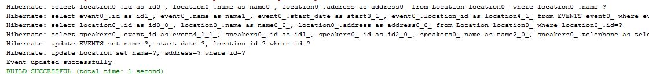

8. Add Speakers:

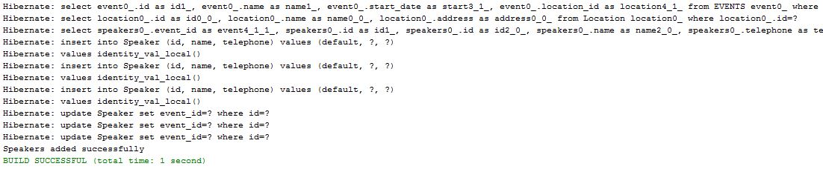

9. Retrieving Events after adding speakers:

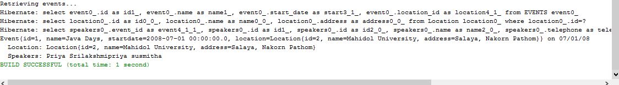

10. Lazy exception:

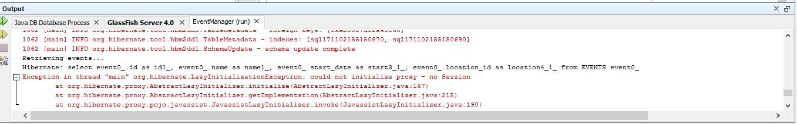

11. After Lazy Exception:

